Hi Sunny –

I have an interesting situation and am wondering if you can help me with another dataframe manipulation project…

I am trying to identify every isolated value in the attached dataframe. My goal is to find all the instances where there is a single number in a cell of the dataframe where there was not a number in the same column on the day before or the day after.

Each column represents a ticker potentially in a hypothetical portfolio. The numbers in each row represent the number of shares of that ticker are held by the portfolio on that particular day. I am trying to isolate occurrences when the ticker was only included for one single day. I consider these to be false positives.

Please see the screenshot below that visually represents the values I am trying to isolate…

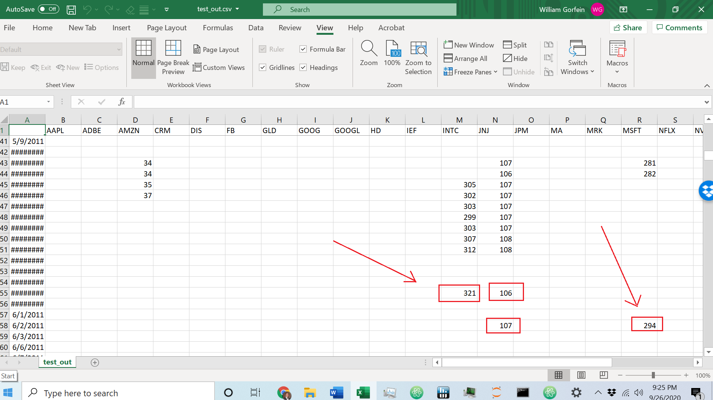

^^^ each of the values highlighted in red does not have either a number in the cell before or after… these are the ones I am looking for.

My goal is for the output to be a second dataframe that contains the same index and columns. Every cell of this dataframe will be False except for the cells where one of these single occurrences is located which will have a value of True.